Polaris cataloging

How to Link authority Records

You can link an authority to a bibliographic, or to another authority record.
You can start from an authority record and link to a bibliographic record or from a bibliographic to an authority record.

Linking a Bibliographic Record to an Authority Record

Bibliographic record | Tools | Check Headings

When a new bibliographic record is saved, or a bibliographic record is updated, Polaris automatically will “Check Headings” or you can “Check Heading” before saving the record.
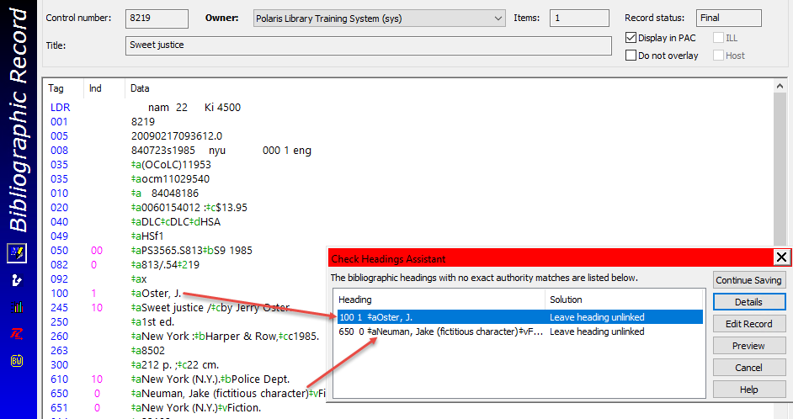

The Check Heading Assistant displays the field with “no exact authority match”
Click Details
If there is a possible authority record, will be displayed
Select the displayed field
Click Adjust to match the entry in the bibliographic record with the authority record
Click OK
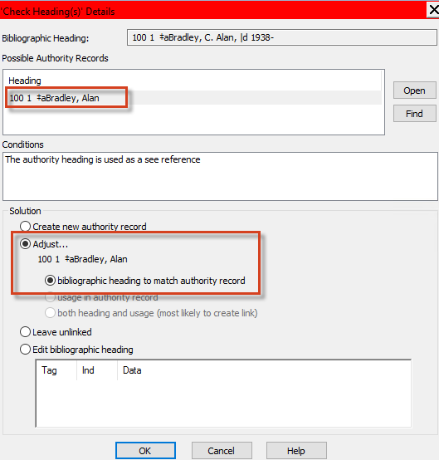

The bibliographic record and the authority records are linked.
In this example, the bibliographic record is linked to two authority records.
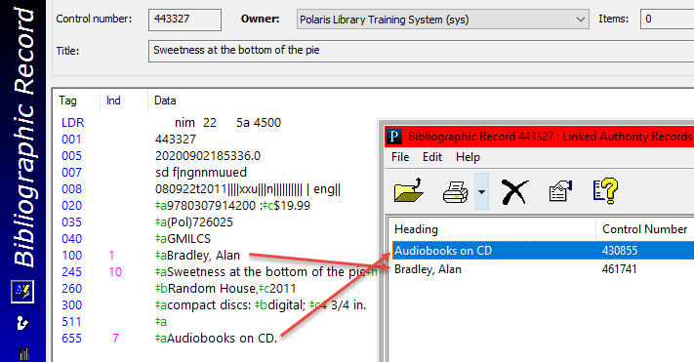

Linking an Authority Record to a Bibliographic Record

Tools | Create Links to Bibliographic Records
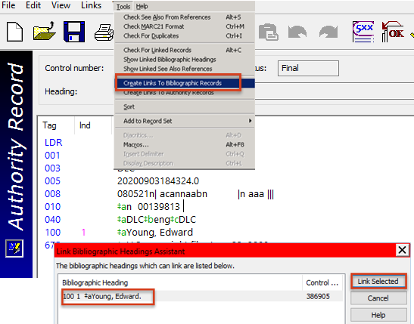

- When creating links to bibliographic records, the Link Bibliographic Headings Assistant dialog box will list all bib records with matching headings
- After clicking the Link Selected button, a job is posted to Utilities | Cataloging Processing | Authority Create Links Queue
- When this job is completed, all appropriate bibs will be linked to the authority record
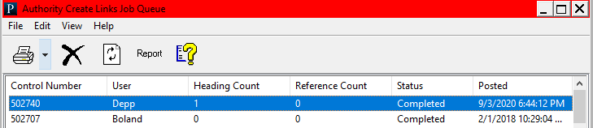

Linking to Other Authority Records

- In the new record, go to Tools | Create Links to Authority Records
- Select the authority records to be linked
- Click the “Link Selected” button.
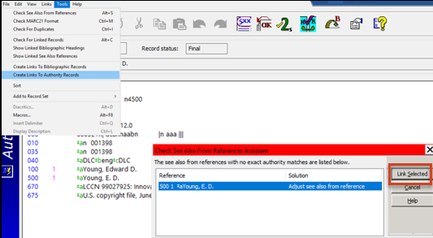

- After clicking the Link Selected button, a job is posted to Utilities | Cataloging Processing | Authority Create Links Queue
- When this job is completed, all appropriate bibs will be linked to the authority record

This publication is supplied for the exclusive use of customers of Innovative Interfaces with the understanding that it shall not be shown or distributed to anyone outside of the customer's organization without the prior written permission of Innovative Interfaces. This publication may be copied only if the copies are for the exclusive use of staff members of libraries that have purchased the Innovative system.
© 2022, Innovative Interfaces, Inc.

