Polaris cataloging

The Anatomy of an Item Record

What is an Item Record
An item record represents a physical or eContent unit, it can also represent a unit of a title on order. An item record cannot exist on its own, it must be attached to a bibliographic record.

The Item Record workform includes cataloging, circulation, notes, notice history, and source information for an item record. If your library uses course reserves functionality, the Item Record workform includes reserve circulation information and linked course reserve records.

Item Views in Polaris Client

- Cataloging
- Circulation
- Source and Acquisitions
- Notes and Notices
- History

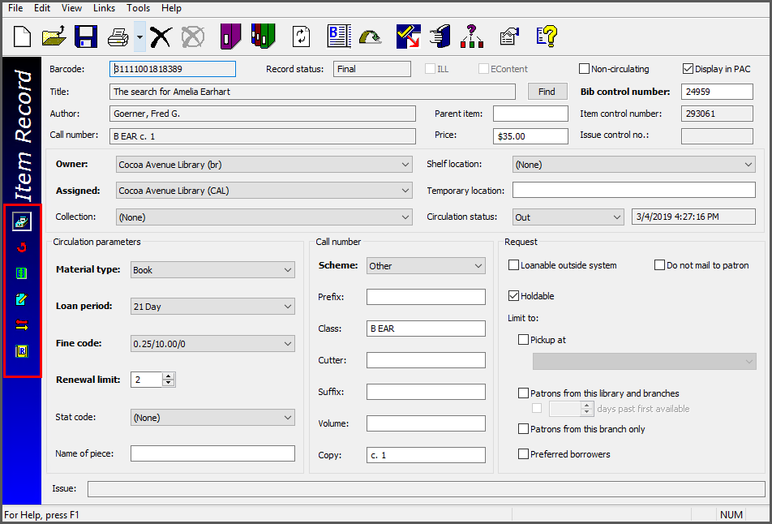

Cataloging View
The first view of an item record is the cataloging view
- A individual staff level profile can be set so that items always open to this view for catalogers
- White fields may be edited, gray cannot
- Bolded fields must be filled in to save the workform

Circulation View
This view shows circulation info, including:
- Current borrower
- Last borrower
- Held for patron
- Last circulated
- Due date

Source and Acquisitions View
The Source and Acquisitions view includes:
- Donor & fund info
- PO and invoice numbers
- Circulation statistics
- Many fields are populated automatically if the item came through the acquisitions process
- The First Available date field is the date that this item became available for check out

Notes and Notices View
This view of an item record holds various notes, notice information and blocks.
- Catalogers can add a library assigned block or a free text block
- Both types of blocks will pop up whenever the item is checked in or out
- If a note is present, the icon turns yellow
- If blocks are present, the icon turns red

History View
The History view of an item record shows each time an item record has been touched.
- Information logged here includes User ID and workstation
- By default this history is saved for a year
- Patron ID may be included in history per a System Administration setting

Course Reserves View
A Reserve Item Record is a special view of the item record linked to a course reserve record.
- Information regarding the reserve item is stored in a reserve item “record.”
- Item on course reserves Information such as assigned branch, assigned collection, shelf location, loan period code, fine code, renewal limit, and holds information. These settings can be different from those in the primary item record.
- Copyright information - If the material is copyrighted, and there is a fee, you can indicate that the fee was paid.
- Ownership information about the item - Copy owner could be library or instructor
- Linked course reserve item information. You can see the course, the reserve status, the dates of the reserve, and the number of circulations (check outs and renewals) of the item while on reserve for that course.

Item Views in Leap
- Details
- Circulation
- Controls
- Blocks and Notes
- History
- Statistics
- Record Sets
- Notices
- Source and Donors

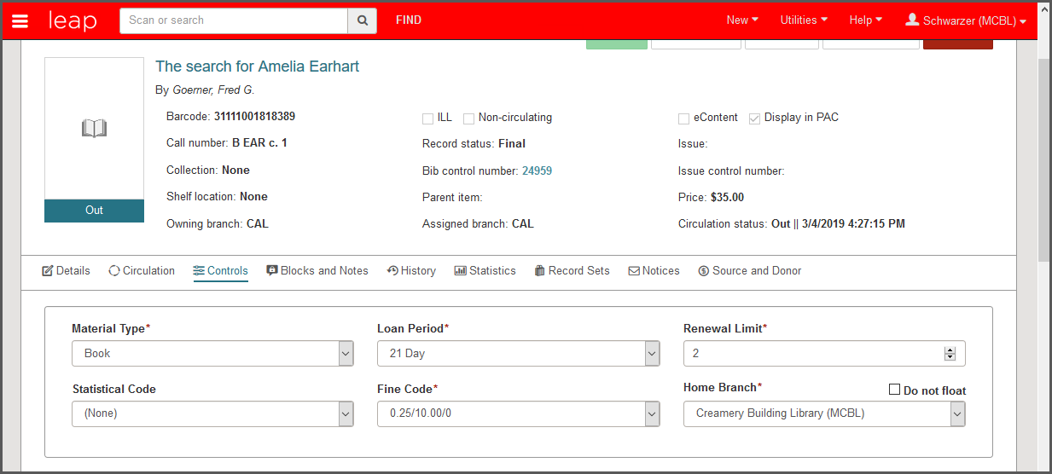

Details View
The first view of an item record is the details view. Staff can edit the following fields in this view:
- Barcode
- Collection
- Shelf Location
- Temporary Location
- Owning Branch
- Assigned Branch
- Price
- Circulation Status

Circulation View
This view shows circulation info, including:
- Current borrower
- Last borrower
- Held for patron
- Last circulated
- Due date
Control View
This view displays controls or settings for the item.
- Material Type
- Statistical Code
- Loan rules (loan period, renewals, fines)
- Call number information including volume
- Hold and ILL rules
Blocks and Notes
This view displays blocks and notes associated with the item.
- Staff can add a library assigned block or a free text block
- Both types of blocks will pop up whenever the item is checked in or out
- If a note or a block are present is present, the icon displays a red flag

History View
The History view of an item record shows each time an item record has been touched.
- Information logged here includes User ID and workstation
- By default this history is saved for a year
- Patron ID may be included in history per a System Administration setting

Statistics
This view displays circulation and inventory statistics for the item.
- Year to date circulation
- Previews year circulation
- Lifetime circulation
- In House circulation including previous year and lifetime
- Inventory date
Record Set
This view displays a table listing all the record sets to which the item record belongs.
- Click on a record set to open it in the Item Record Set workform.

Source and Acquisitions View
The Source and Acquisitions view includes:
- Donor & fund info
- PO and invoice numbers
- Many fields are populated automatically if the item came through the acquisitions process
- The First Available date field is the date that this item became available for check out

Notices View
This view of an item record notices.
- 1st through 3rd notices sent to patrons
- Hold notice
- Bill

Specifying the Item View

You can specify the view that appears when you first open the Item Record workform. Setting them at the staff member level can accommodate the workflows of specific staff members. For example, a cataloger may want the Item Record workform to open to the cataloging view every time she opens the workform, regardless of whether the workform is opened to create a new record or an existing item record is opened from a Find Tool results list.

- Polaris Staff Client specify the item view – in the Polaris Administration, select Profiles, then select the Staff Client tab, the Default view selected when item record opened.

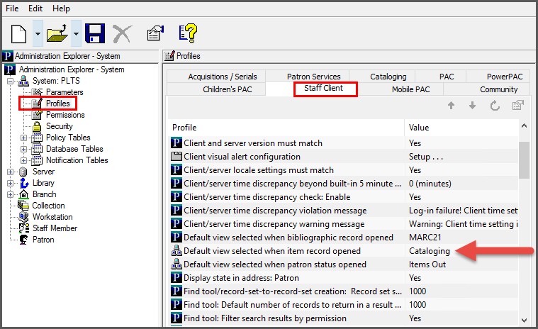

- In Leap specify the item view in – Settings

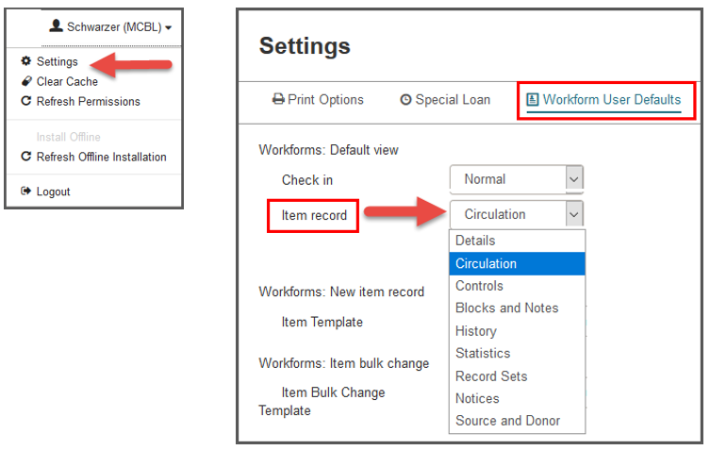

This publication is supplied for the exclusive use of customers of Innovative Interfaces with the understanding that it shall not be shown or distributed to anyone outside of the customer's organization without the prior written permission of Innovative Interfaces. This publication may be copied only if the copies are for the exclusive use of staff members of libraries that have purchased the Innovative system.
© 2022, Innovative Interfaces, Inc.

