Polaris cataloging

How to Create Item Records

What is an Item Record?

An item record represents a physical or eContent unit, it can also represent a unit of a title on order. An item record cannot exist on its own, it must be attached to a bibliographic record.

Create a New Item Record
From the bibliographic record, click the Create Item Records icon
The New Item Record Options box will appear

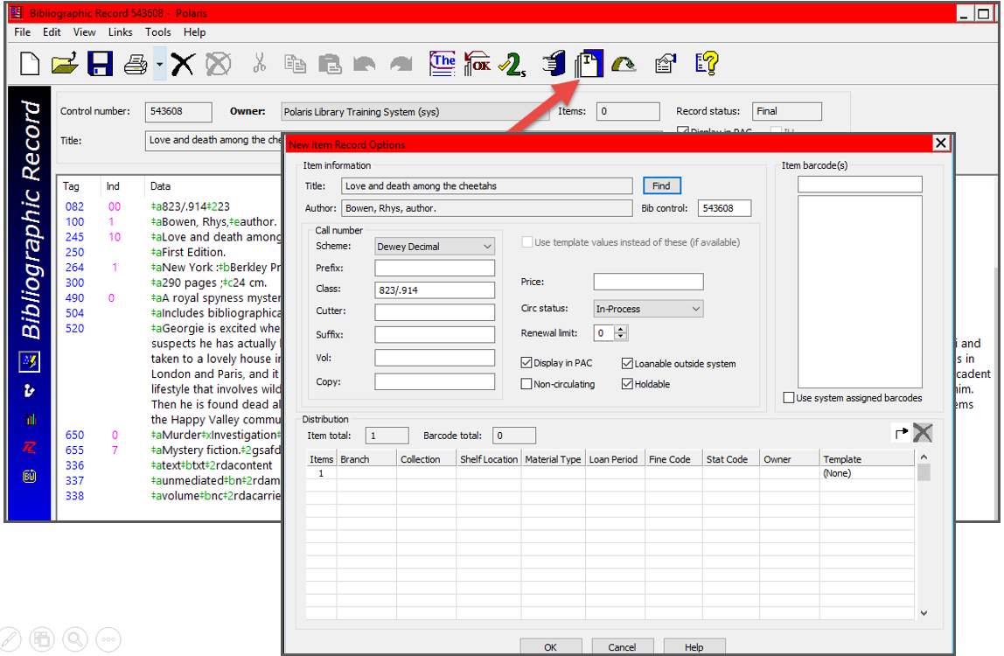

Note: If your library adds call numbers to bibs, each piece of the call number can have its own subfield defined in the call number hierarchy.

- Verify that the call number is correct, add the price if desired.
- Select the correct item template(s) from the template dropdown--any of the defaults can be edited in the grid.
- Verify the creation of the correct number of items for each branch.
- Scan in barcodes if you wish the bulk create to provide the barcode.
- Click OK to bulk create the items.

Note: Barcodes may be added one of three ways: In the New Item Record Options dialog box, barcodes can be scanned in or use System Assigned Barcodes. They may also be scanned into individual item records after they have been created.

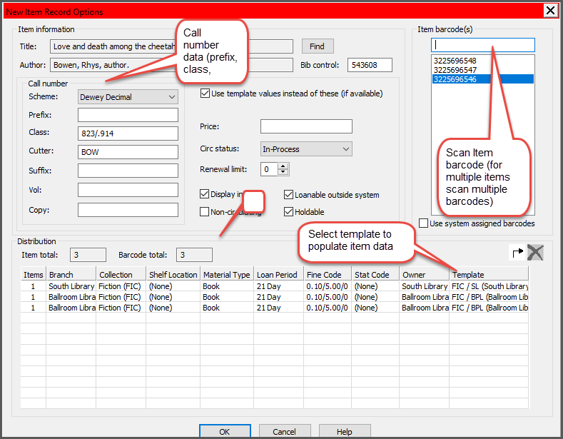

- If only one item record was created, it will automatically open.
- If multiple items were created, a list of item records will appear.
- Open the first item for review--you may scan in a barcode if not bulk added.
- Staff can easily move through the list of items by going to View/Previous (Ctrl/E) or Next (Ctrl/R) record.

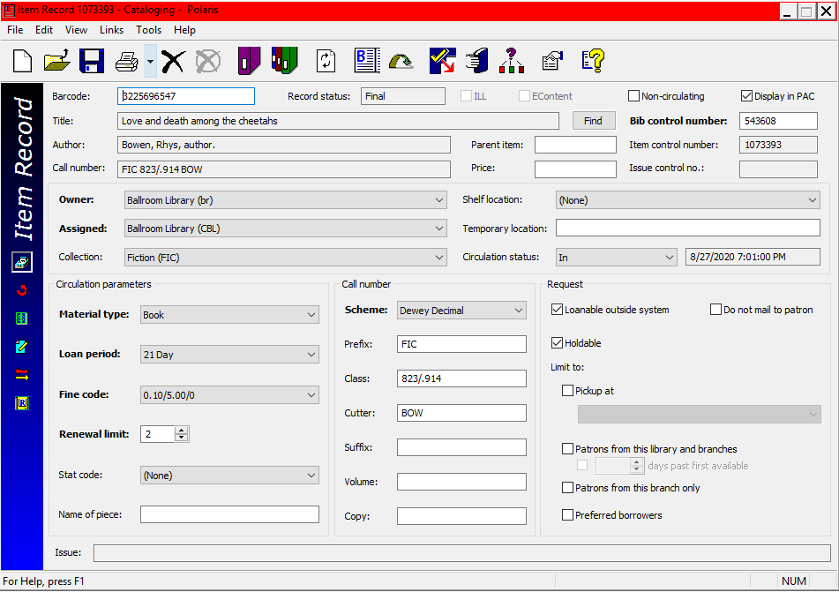

This publication is supplied for the exclusive use of customers of Innovative Interfaces with the understanding that it shall not be shown or distributed to anyone outside of the customer's organization without the prior written permission of Innovative Interfaces. This publication may be copied only if the copies are for the exclusive use of staff members of libraries that have purchased the Innovative system.
© 2022, Innovative Interfaces, Inc.

