polaris acquisitions

Supplier Records

Supplier records

The supplier record contains the vendor address, default currency, EDI (Electronic Data Interchange) information and the default claiming cycles for a vendor. If there are multiple accounts with one supplier, there must be a separate supplier record for each account number.

Creating a new Supplier Record

Follow these steps to create a supplier record. Once the first supplier record is created, it can be copied to create additional supplier records. Like most Polaris records, the supplier record is divided into separate sections. Follow these steps to complete the General section. Then move to the next sections to complete the record.

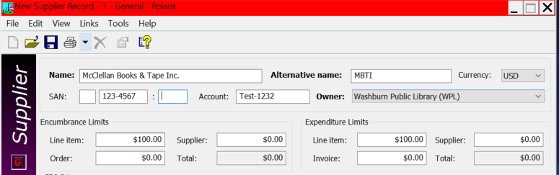

- Select File>New or click on the New icon.
- In the object box select Supplier Record in the objects box and click OK.
- Type the supplier’s name in the Supplier Name box.
- Optional – type and alternative supplier name in the Alternative name box
- Type the seven-digit standard address number of the supplier in the SAN box
  - The SAN is required for EDI orders.
  - If you select Accepts EDI orders, you cannot save the supplier record without the seven-digit SAN.
  - The “-“(hyphen) is for display only; it is not transmitted electronically.
  - Polaris does not validate that you typed the correct vendor SAN so confirm it is correct.
- Type the library’s account number (or SAN suffix) in the Account no. box.
- Select the library that owns the account in the Owner box.
- Optional – enter dollar amounts for the supplier, order and line item encumbrance and expenditure limits in the appropriate boxes. This information is for reference only. It does not prevent over encumbrances or over expenditures.
- If the supplier accepts EDI orders, enter the communications information. For additional information see supplier EDI info section in this document.
- Optional – type notes for this supplier in the General box. You can enter up to 400 characters in this field.
- Optional – type plan information in the Plan note box if your library has an approval or blanket purchasing arrangement with this supplier. You can enter up to 400 characters.
- Add the supplier address information.
- Add the claiming criteria for this supplier.
- Select File>Save to save the record and move to the Orders View.

Orders view

Enter in this section the address information and contact information for your supplier.

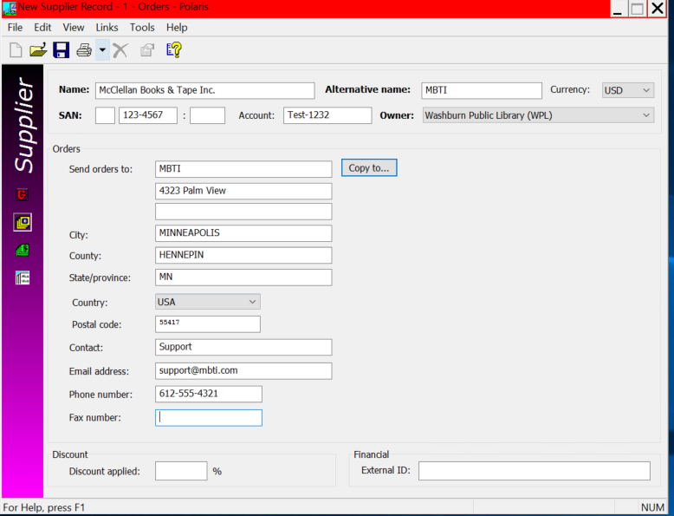

- Type the supplier’s name and street address in the Send orders to: box
- Select or confirm the country in the Country box
- Type the postal code (zip code) in the Postal code box.

- Type the contact person’s name in the Contact box.
- Type the supplier’s e-mail in the Email address box.
- Type the supplier’s phone number in the Phone no. box
- Optional – type the supplier’s fax number in the Fax no. box.
- Optional – type the supplier’s discount percentage in the Discount applied box.
  - This discount percentage is applied to all purchase orders using this supplier but can be changed in the purchase order.
  - If you change the discount percentage in the supplier record, when saving a message will list any linked purchase orders and ask if you want to update the discount percentage in these templates.

Payments and Claims view

If the supplier’s address information for sending payments and claims is the same, use the Copy to option. If not proceed to those views and enter manually using the same steps as previously listed.
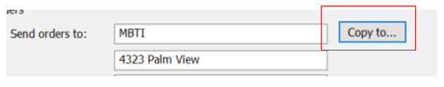

Claims view

In addition to the address and contact section there is an additional section setting up the claiming criteria. This section must be completed before any items can be claimed. The supplier claiming criteria is copied to the purchase order templates, purchase orders, and purchase order line items linked to this supplier record. You can adjust the claiming criteria as needed in these records. What is entered into the supplier record are the default criteria.

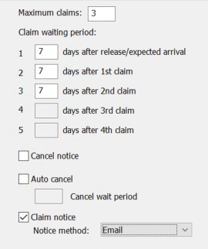

- Maximum claims – the number of claims (up to 5) the library will submit to the suppler before cancelling ordered items.
- Days after release/expected arrival – the number of days between the time a purchase order line item is released to the time the first claim is generated.
- Claim waiting period – enter the number of days that must pass after the release/expected arrival and subsequent claims.
- Select the Cancel notice box to generate a cancellation notice.
- Select the Claim notice box to generate a claim notice.
- Select the method by which to send notices in the Notice Method box.
- Select Auto Cancel to cancel purchase order line items automatically after the claim cycle is over.
- Type a number in the Cancel wait period box to indicate the number of days to wait after the last claim is sent before canceling items ordered from this supplier.

EDI ordering data

To send orders electronically via EDI, the supplier record must contain the correct EDI ordering information. You must contact the vendor and get the required information to enter in Polaris.

Individual supplier records will be needed for each Enriched EDI account if using.

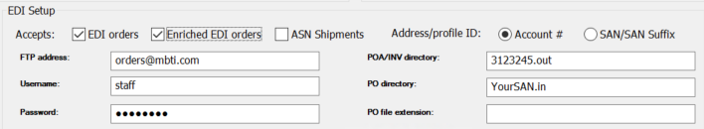

- Select the EDI orders check box. Required fields are in bold type.
- If the vendor is providing shelf-ready cataloging services check the Enriched EDI orders check box.
- If the vendor provides an advanced shipping notice, select ASN Shipments.
- Select the Account # or SAN/SAN Suffix to indicate the address or profile ID. Your Polaris Site manager will confirm this information.
- Type the FTP address in the FTP Address box
- Type the File Transfer (FTP) username in the Username box.
- Type the FTP password in the Password box.
  - The password does not appear as you type it.
- Type the directory for the purchase order acknowledgement and invoice in the POA/INV directory box.
- Type the directory for the purchase order in the PO directory box.
- Type the file extension for the purchase order in the PO file extension box.
- Select File>Save.

This publication is supplied for the exclusive use of customers of Innovative Interfaces with the understanding that it shall not be shown or distributed to anyone outside of the customer's organization without the prior written permission of Innovative Interfaces. This publication may be copied only if the copies are for the exclusive use of staff members of libraries that have purchased the Innovative system.
© 2022, Innovative Interfaces, Inc.

