polarios acquisitions

Shelf Ready Ordering Enriched EDI Setup

Receiving Shelf Ready Items

- Checking in shelf-ready materials in branches
- Using auto-receive when receiving centrally

Checking in shelf-ready materials in branches

- To access the Check In Shelf-Ready Materials workform, go to Acquisitions/EDI Services/Check In Shelf-Ready Materials on the Polaris Toolbar

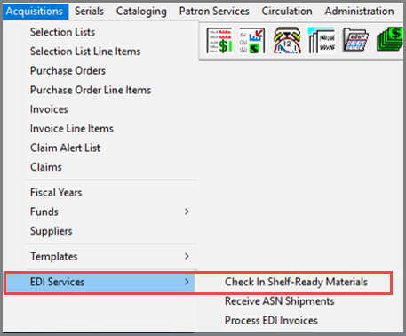

After selecting Check-In Shelf Ready Materials, the receiving workform opens up.
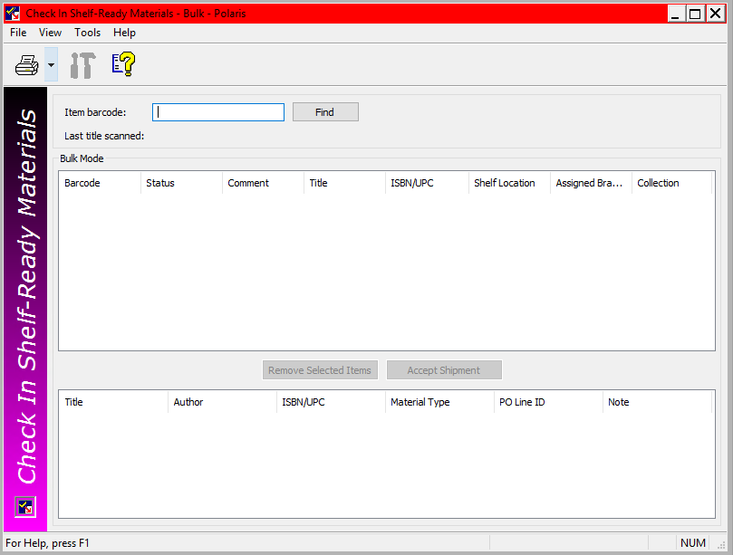

- To use the Receive Shipment workform, there must be a matching on order item record with a barcode in the database
- If no matching item or POLI is found, an error message will appear

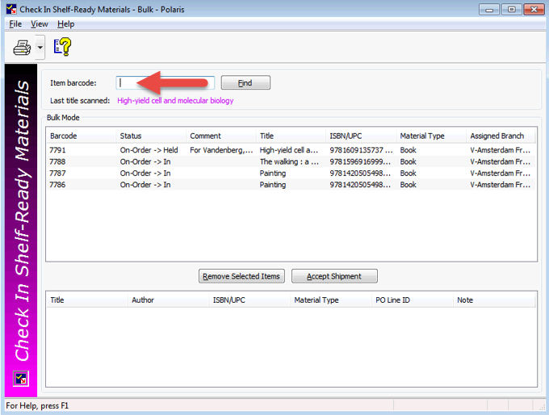

- To use the Receive Shipment workform, there must be a matching on order item record with a barcode in the database
- If no matching item or POLI is found, an error message will appear
- The Fill Hold dialog box will appear if an item can satisfy a hold or be transferred to another branch for a hold

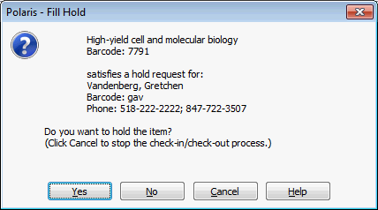

- Once an item is scanned and appears in the list, staff can right-click on it to perform other tasks such as placing a hold or linking to another record
- Use the Remove Selected Item button if an item was received in error

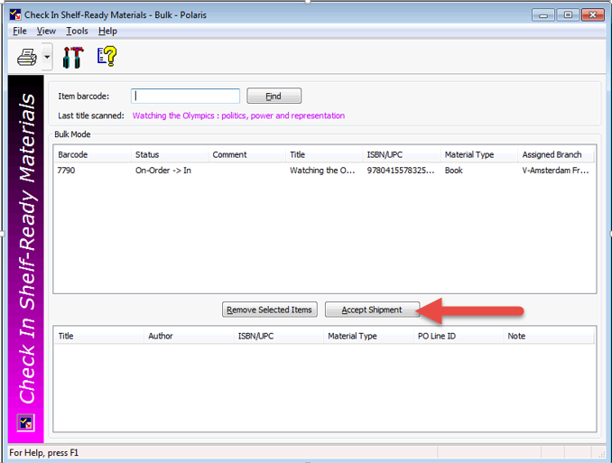

The received items (after clicking on the Accept Shipment button), display on the lower part of the form.

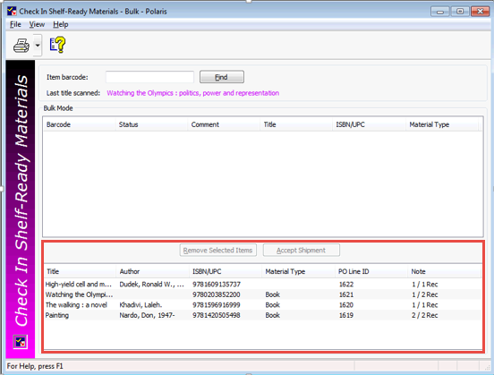

Using Auto-Receive when Receiving Centrally

- If items will be received centrally, turning on ‘Update linked PO line item to received’ is an option.
- When an EDI invoice is brought into Polaris, matching POLIs will automatically be updated to received.
- Hold partial shipment invoices can also be used so that titles that are not received complete can easily be split when manually bringing in the invoice.

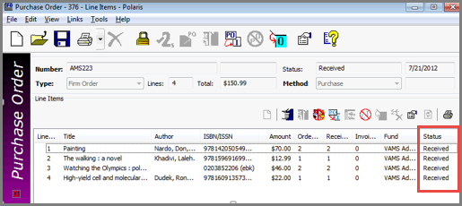

Reports for shelf-ready materials

- Check in shelf-ready materials
- Shelf-ready items not received in acquisitions

- The check in shelf-ready materials report shows items received in a branch during a specific date range.
- The shelf-ready items not received in acquisitions report shows all items that have not be checked in at a specific branch.

This publication is supplied for the exclusive use of customers of Innovative Interfaces with the understanding that it shall not be shown or distributed to anyone outside of the customer's organization without the prior written permission of Innovative Interfaces. This publication may be copied only if the copies are for the exclusive use of staff members of libraries that have purchased the Innovative system.
© 2022, Innovative Interfaces, Inc.

