polaris acquisitions
Troubleshooting Bibs with Multiple ISBNs During Bulk add PO

If a bibliographic record contains only two ISBNs, and they are identical with the only difference being that one is the 13-digit equivalent of the 10-digit ISBN, then the 13-digit ISBN will be loaded in the top-most position, regardless of its order in the bibliographic record.

However, when a 020 subfield z is present Polaris functions differently because the $z is viewed as a third ISBN. When bulk adding a bibliographic record to a PO and a bibliographic record has multiple ISBNs or UPCs, the last, most-recently added ISBN (and associated price), or the last, most-recently added UPC displays in the first, top-most position in a purchase order line item or selection list line item. This is true whenever multiple, non-matching ISBNs are present in a bib record.

Since there is a chance for the wrong ISBN to be added to a POLI whenever multiple ISBNs are present, there is a system administration setting to add an alert (!) to the POLI when the bibliographic record contains multiple ISBNs (Parameters > ACQ/Serials > Bulk add to PO: Add alert to PO line item for multiple ISBNs).

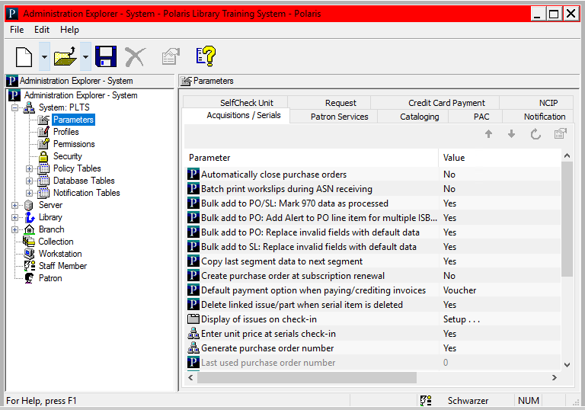

Note: It may be useful to speak your library's book vendor. They may provide a MARC profile setup that will allow you to strip out, upon export, unnecessary tags including 10-digit ISBNs, when the 13-digit ISBN is already present in the bibliographic record.

This publication is supplied for the exclusive use of customers of Innovative Interfaces with the understanding that it shall not be shown or distributed to anyone outside of the customer's organization without the prior written permission of Innovative Interfaces. This publication may be copied only if the copies are for the exclusive use of staff members of libraries that have purchased the Innovative system.
© 2022, Innovative Interfaces, Inc.

