Polaris Acquisitions

How to Create a Credit Memo

Introduction
This article explains how to credit a specific fund(s) without linking to an invoice line item.

New Invoice:
Use the Polaris Toolbar, File>New and Choose Invoice
- Name the invoice according to your library guidelines
- Choose TYPE: Miscellaneous
- Link to the correct Supplier record
- Click the Save button
- Navigate to the 2nd view of the Invoice

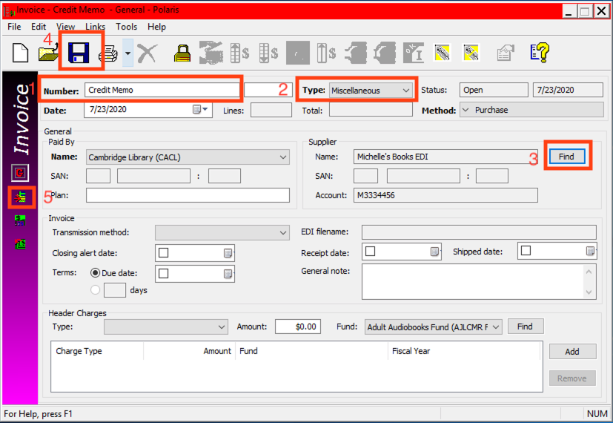

On the 2nd view of the Invoice, use the Mini Toolbar to add a new line to the invoice:

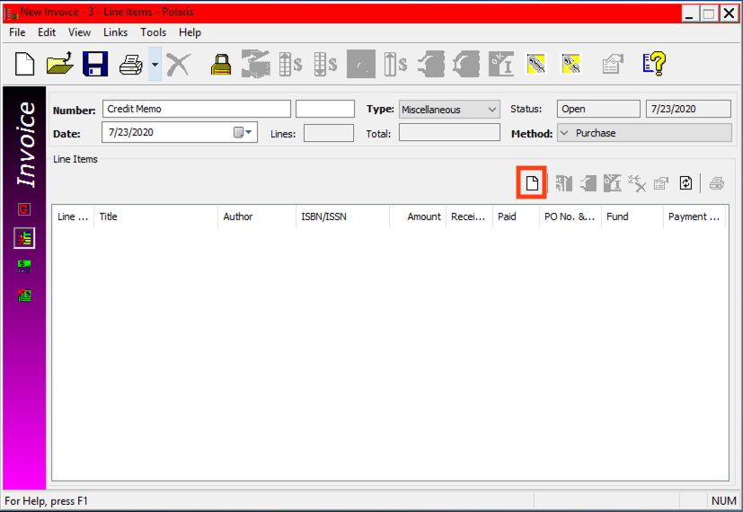

This will open a new Invoice Line Item:
- Title: Choose whatever makes sense in your workflow/library
- Unit price: The amount that you are wanting to credit
- Quantity: Change from 0 to 1
- Choose the correct fund to credit
- Hit save and close the invoice line.
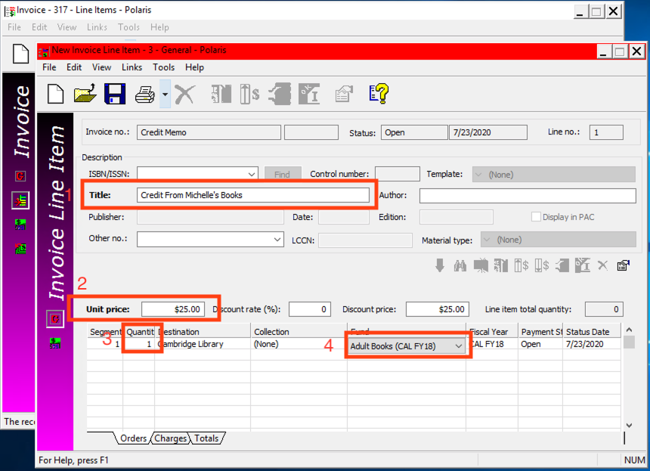

Back on the invoice, navigate to the Tools drop down menu, and choose Credit:
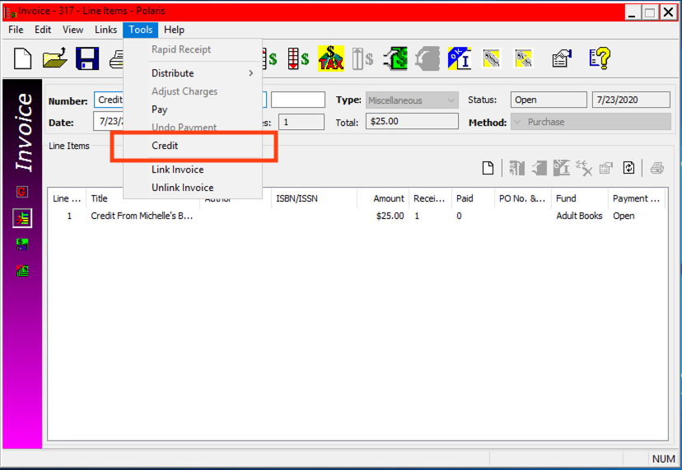
Click OK when the box pops up:
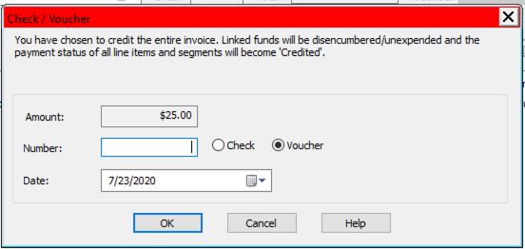

The invoice line will have a status of Credited (as does the line):
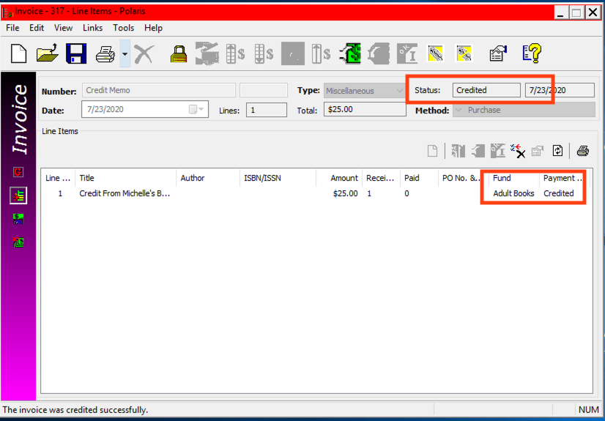

This will unexpend the amount in the fund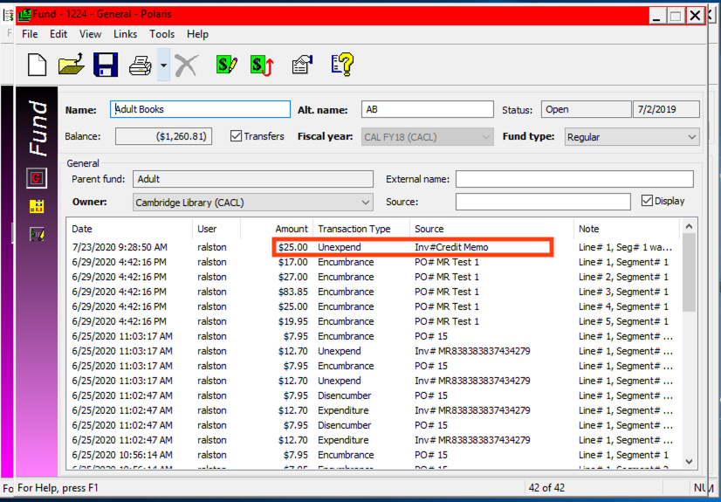

This publication is supplied for the exclusive use of customers of Innovative Interfaces with the understanding that it shall not be shown or distributed to anyone outside of the customer's organization without the prior written permission of Innovative Interfaces. This publication may be copied only if the copies are for the exclusive use of staff members of libraries that have purchased the Innovative system.
© 2022, Innovative Interfaces, Inc.

