Innovative Mobile

How to Add an RSS News Feed to your Library's App

If your library uses an RSS news feed to inform your patrons about library events, you can add the RSS news feed to your library's Mobile app.

To add an RSS news feed to your library's app
- From the menu in the CMS, choose Content.
- Choose Add new Content.

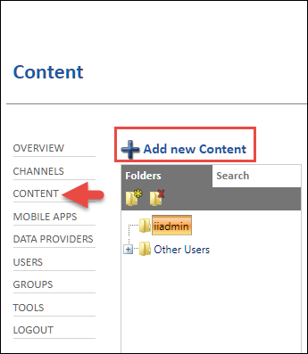

- Choose RSS News Feed.

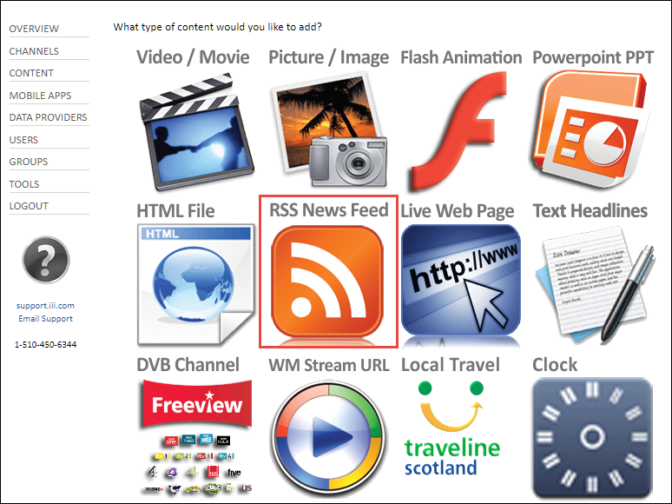

- In the Name field, type a name to describe what the RSS news feed is for.
- In the News Feed field, type the URL for the RSS news feed.
- In the Publish section, select Mobile.

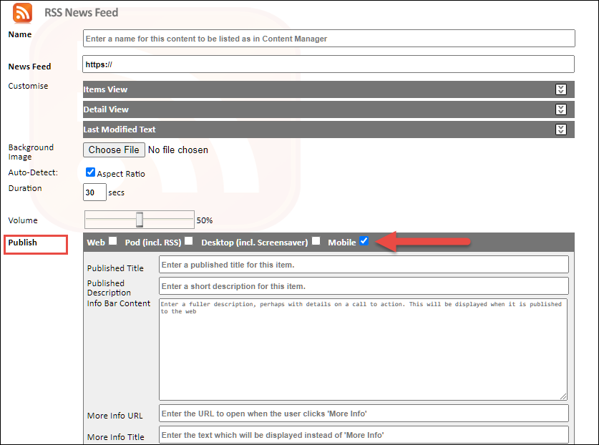

- If you want to include a thumbnail image with the content, click Advanced, then select the image you want to include.
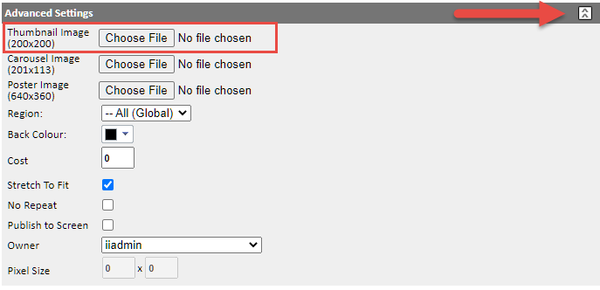

- Note: The optimum size for a thumbnail is 200 x 200 pixels.
- Leave the rest of the fields on the page unchanged. These other fields do not have any effect on how the RSS news feed is displayed in the App.
- Choose Create.
- From the menu in the CMS, choose Mobile Apps.
- Select the folder node where you want to add a tab for your RSS news feed and choose New Tab ( ).

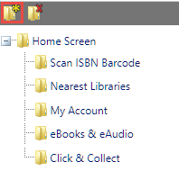

- Type a name for the tab, then choose Create. The name that you choose is the text that displays in your library's app.
- Select the tab that you created and choose Edit Tab: [your tab name].
- If you want an image to be displayed next to the name of the tab in your library's app, choose Browse next to Button Image, then select an image from your computer to upload.
- In the Tab Contents section, select Content Item, then select your RSS news feed from the drop-down list.
- Choose Save.
- Patrons who are already using your library's app will see your changes in about 2 hours. Patrons will see your changes instantly if they load your app for the first time or if they manually reload the app from the Preferences screen. You can manually reload the app on your own device to test any changes that you've made.

This publication is supplied for the exclusive use of customers of Innovative Interfaces with the understanding that it shall not be shown or distributed to anyone outside of the customer's organization without the prior written permission of Innovative Interfaces. This publication may be copied only if the copies are for the exclusive use of staff members of libraries that have purchased the Innovative system.
© 2021, Innovative Interfaces, Inc.

